Project Overview
Embellish any graphic design with Illustrator Symbols and Symbol Sprayer.

Final:
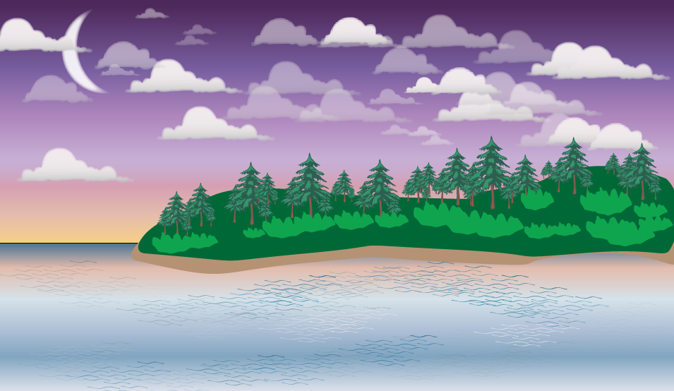

Part 1 - Create a New Illustrator Document

Create and Save a New Blank Document
- Create a new Web document using the RGB defaults
- Name it Designing With Symbols.ai and save it in your project folder
- Choose View > Show Rulers

Part 2 – Create the Gradient Background
Open the Sky Swatch Library
- Swatches > Open Swatch Library > Gradients > Sky

Draw a rectangle approximately 2/3 of the height of the artboard aligned top (the sky)
- Fill the rectangle with Sky 19
- Adjust the Gradient angle to -90⁰

Draw a rectangle approximately 1/3 of the height of the artboard aligned bottom (the water)
- Fill the rectangle with Sky 6
- Adjust the Gradient angle to 90⁰

Modify the Gradient Stops
Change one or more gradient stops on the bottom rectangle to match a few gradient stops in the top gradient. For example, from the top rectangle I selected the and 2nd stop (E3BCAD) from the right and modified one of the Gradient stops on the bottom rectangle to these colors.

Rename the layer Background
- Lock it and create a new layer, name it Clouds

Part 3 - Symbol Spray the Clouds
From the Symbol panel menu, choose:
- Open Symbol Library > Nature
- Select Cloud 1

Double-click the Symbol Sprayer tool to see its options
- I set my diameter to 100 px
- Spray clouds over the top rectangle

Tear-off the Symbol tool to make all of the Symbol options more easily accessible
- Experiment all of the other Symbol adjustment tools and the Alt key
- Spray Cloud 2 and Cloud 3 Symbols
- Modify them using the Symbol adjustment tools
- Experiment with multiple Symbol Sets in the Layer

Lock the Clouds layer, create a new layer, name it Land

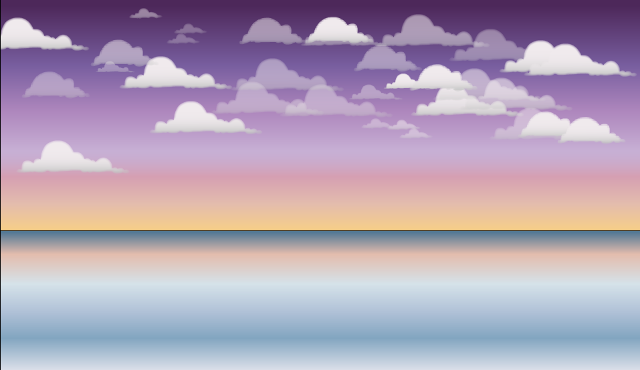

Part 4 - Create the Land Mass and Sandy Beach
- Select the Pen tool
- Choose a dark green color
- Create a shape that looks like the smooth curves at the edge of a land mass over about
75% at the horizon

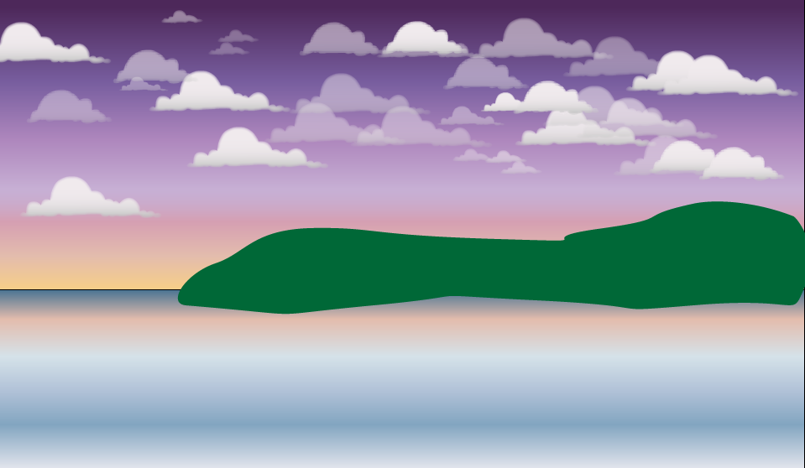

- Duplicate the shape and change to color to a light tan color for a shoreline/sand

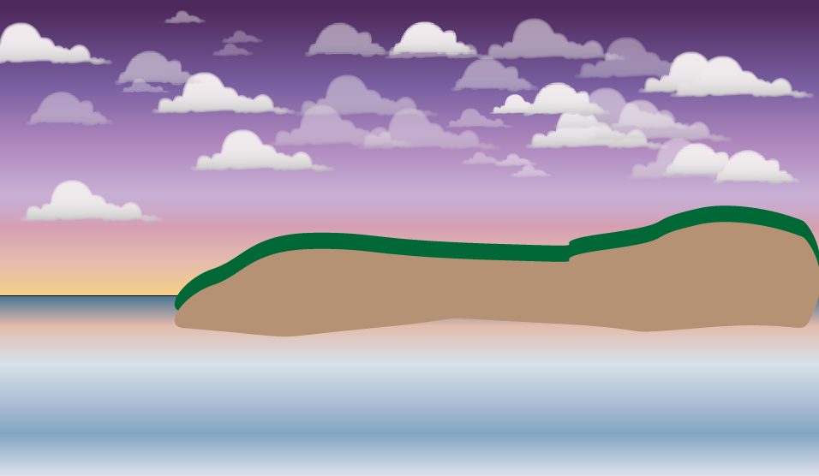

- Position the sand behind the land and adjust points using the direct select tool to extend part of the sand beyond the land
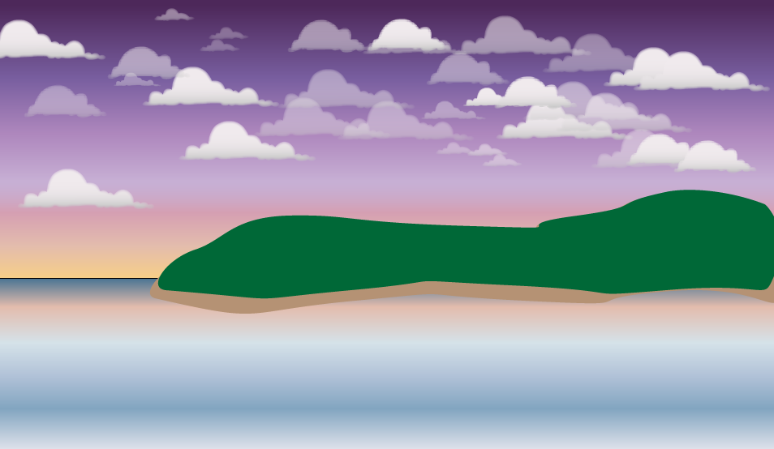

Lock the Land layer, create a new layer, name it Trees

Part 5 - Add Trees and Re-Size Them
From the Symbol panel menu, choose:
- Open Symbol Library > Nature
- Select Trees 1

Double-click the Symbol Sprayer tool to see its options
- I set my diameter to 50 px
- Spray Trees over the Land
- Use the Symbol Sizer and Scruncher tools to re-size and adjust the spacing

Lock the Trees layer, create a new layer, name it Shrubs

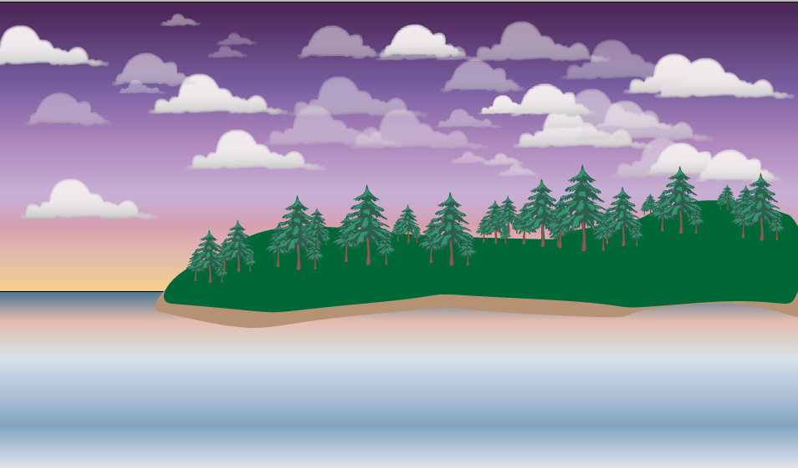

Part 6 – Create a New Symbol (Shrub) and Spray It
Using the Pen tool
- Draw a shape that looks like a shrub using a complimentary green color

- Select Shrub and add it as a new Symbol
- Select the Symbol Sprayer tool
- Spray the Shrub covering the bottom of the trees
- Use the Symbol Sizer and Scruncher tools to re-size and adjust the spacing

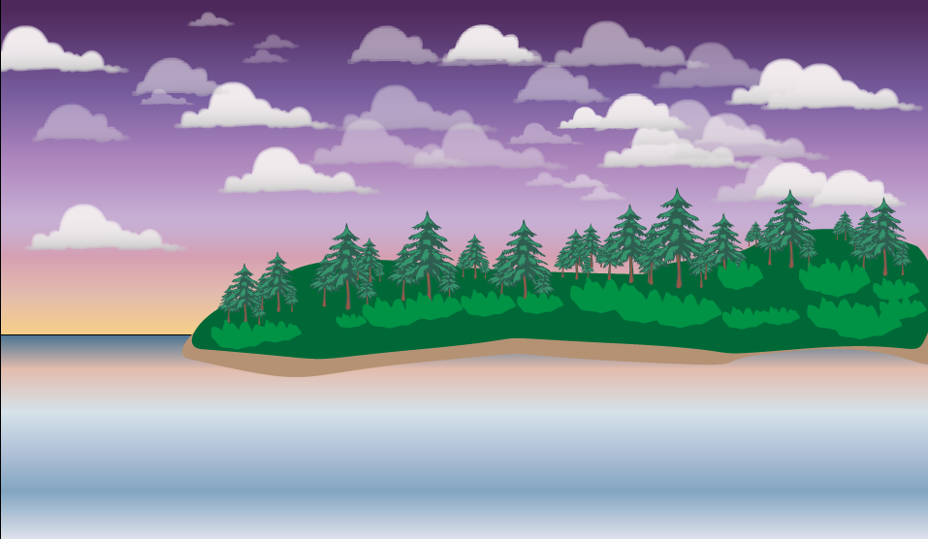

Part 7 – Adjust the Shrub Symbol
- Drag the Shrub Symbol to the artboard
- Break Link to the Symbol in the Symbol Panel (this enables you to change the color)
- Change the color to a lighter shade of green
- Alt-Drag the Shrub Symbol from the artboard over the existing Shrub Symbol in the panel (this changes all instances of the Symbol on the artboard)
- Delete the extra Shrub Symbol from the artboard

Lock the Shrubs layer, create a new layer, name it Water Ripples

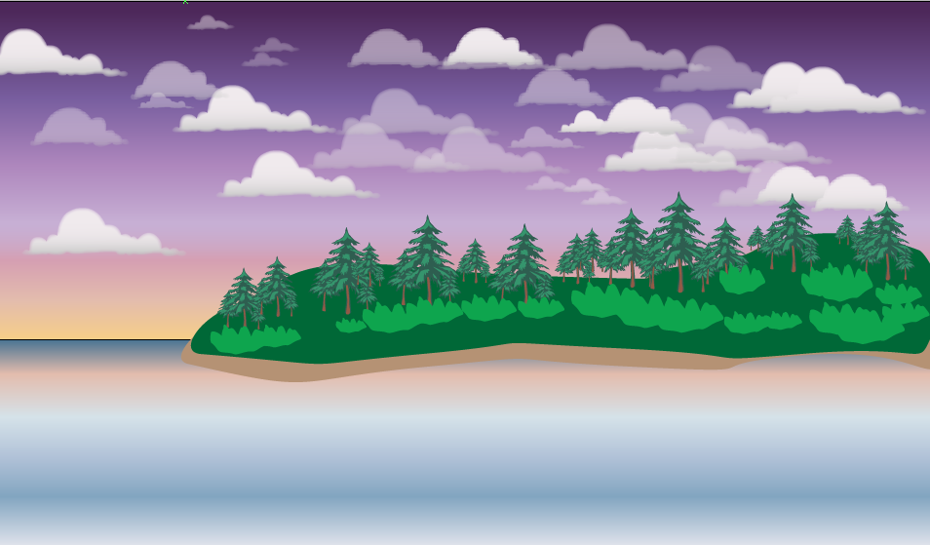

Part 8– Spray Water Ripples with Texture
- Open the Symbol Library > Artistic Textures
- Spray the Ripples texture over the water
- Use the Symbol Screener tool to add transparency
- Select the Symbol Stainer tool
- Select a dark blue color
- Apply the Symbol Stainer
Define a new Symbol Set in this layer
- Repeat the process and spray with the Ripples texture
- Apply a white or light color with the Symbol Stainer

Lock the Water Ripples layer, create a new layer, name it Moon

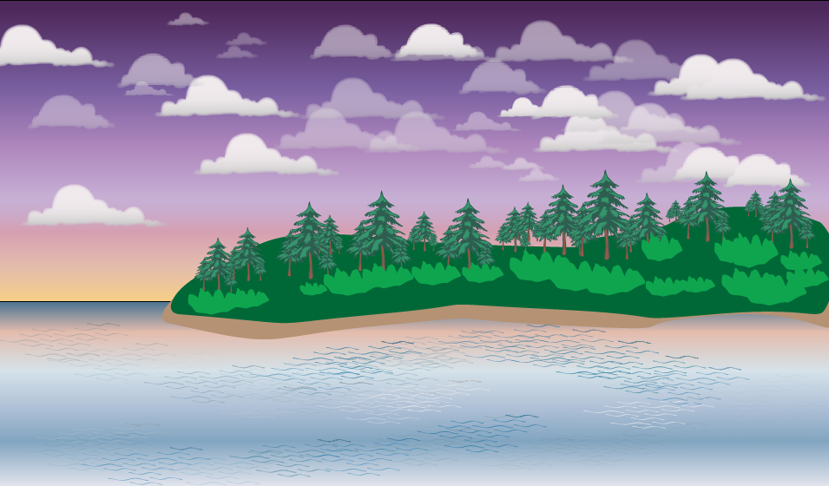

Part 9 – Add a Moon
- Using the Ellipse Shape and Pathfinder, create a Moon
- Soften the Moon with an Effect > Stylize > Feather
- Move the Moon layer below the Clouds layer
- Reduce the Opacity to 90% in the Appearance panel

Part 10 – Crop using a Clipping Mask
- Add a new layer on top
- Draw a rectangle over the artboard
- Unlock all layers
- Object > Clipping Mask > Make

