Creating a Corporate Identity
For these projects, you’ll create a logo, a business card, a letterhead, and a standard #10 envelope for a fictitious company, REACH. This company provides goal-setting workshops and tutoring for children and teens, encouraging them to achieve their dreams through focused effort. There are many other tutoring companies out there, and REACH has hired you to give it an identity that will set it apart from others and that will clearly define its niche in the market. In an effort to communicate its vision, REACH has decided to use the tag line “Learn. Grow. Succeed.”
Project files: http://www.asciutto.com/dg

Project 1 - Creating the Logo
The first step is to create a logo for REACH. It’s best to create logos in Illustrator because vector art is scalable to any size. It’s also easier to repurpose the art for print or Web use, as well as to easily apply spot colors, if necessary. The logo you’re going to create for REACH will consist of a type treatment and an illustration.
The final logo will look similar to this:

Task:
- Launch Adobe Illustrator and create a basic CMYK document

Choosing a Typeface
Choosing a typeface is obviously one of the most important parts of designing a logo. Although it might be fun trying to find a totally unique font to use, remember that a logo has to be clear and readable. It’s not just by coincidence that so many logos are set in fonts such as Helvetica or Garamond. You can always add little tweaks to the type afterward to give it a unique look, if necessary. Try applying different fonts to the type to get the look you want. I chose Myriad Pro because I think it gives a clean, confident look.
Task:
- Type the word “REACH”, I used the font Myriad Pro, size 86
- Set the Kerning to ‘Optical”
- Set the tracking amount to –18 to pull the letters toward each other
- Feel free to experiment with other Character options
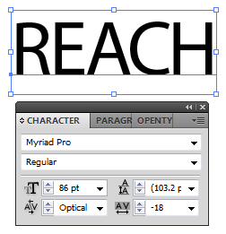
Task:
- Start a new line of text and type the tag line ”learn. grow. succeed.”
- Myriad Pro, size 24
- Set the Kerning to ‘Optical”
- Set the tracking amount to 25
- Position the tag line below the word "REACH”
- Group the words together


Now you’ll want to convert the text to outlines. This is usually a good idea with a logo, making it easier to send the logo to others without worrying about fonts. The last thing you would want is to have your logo look completely different just because the person who opened it on another computer didn’t have your exact font. To convert the text to outlines, select the Type object and choose Type, Create Outlines. The typography part of the logo is now complete.

Creating an Illustration
To add a graphic element to the logo, you can create an illustration that can quickly help identify what REACH does or represents. Because the company represents reaching for your dreams, here you’ll create the image of a hand reaching for the stars. Rather than attempt to actually draw a hand and stars, you’ll employ Illustrator’s Live Trace feature to help create a realistic illustration that will surely draw attention. Remember that because you’re creating this in Illustrator, it will be easy to repurpose this design element for other needs.

Task:
- Choose File, Place, and navigate to the folder of images and locate the file “dream-catcher.jpg”
- With the image still selected, double-click the Scale tool, enter a value of 20% in the Uniform field, and click OK

Using raster images in a logo is usually not a great idea because if the logo needs to be scaled up in size, you will lose resolution and detail. The Live Trace feature in Illustrator enables you to convert this pixel-based image into a vector-based image and also enables you to customize the look of the image. The result of the Live Trace is a more stylized image because of the posterization that occurs as a result of a reduction to fewer colors.
Task:
- Select the image, click the Tracing Presets and Options icon in the Control panel, and choose Comic Art
- Choose Expand (Expanding a traced object allows you to edit points along its paths)
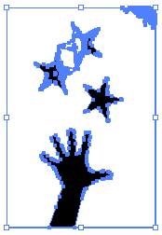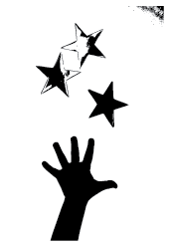

To remove unwanted points, choose the Direct Selection tool, select the mess of points at the upper right, and press Delete on your keyboard. Do the same for the top two stars. Don’t worry—you’ll replace them with copies of the bottom star. Also delete the corner points at the upper left, lower left, and lower right.
As long as you’re cleaning up, now is a good time to point out that Live Trace makes both shaded and white shapes, which can be confusing when you start moving and changing the tracings. To remove them, switch to the Selection tool, select the traced objects, and choose Object, Ungroup. Select the shaded shapes and nudge them of the way, and then click areas where there might be white shapes and delete them. Note that all of the pieces of the traced image are grouped and you will need to use the Direct Selection tool to move individual parts. However, you can use the regular Selection tool if you ungroup the object.
Task:
- Use the Direct Selection tool to remove two stars and clean-up the remaining star
- Duplicate the remaining star two times and randomly rotate them



You will now change the appearance of the traced object by using different shades of gray instead of black. Choose Swatch Library from the Swatches panel and open the Metal library. Now that the library is open in your document, you can use these colors for your traced objects.
Task:
- Choose Swatch Library from the Swatches panel and open the Metal library
- Set the star just below it to a medium gray and the bottom star to a light gray
- For the reaching hand, echo the dark gray of the top star to bring visual coherence

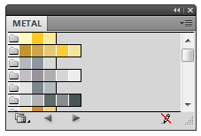
Now, you’ll create a border by surrounding the hand and stars with a rectangle.
Task:
- Choose the Rectangle tool, select light gray fill color and black stroke
- Set the stroke to 4 pts
- Draw a rectangle around the hand and stars
- Set the rectangle behind the hand and stars by choosing: Object – Arrange – Send to Back
- Adjust the rectangle size to your taste
- Group it


To complete the logo, position the text you created earlier to the right of the rectangle.
Task:
- Position the text and picture together
- Group it
- Save it as “logo.ai”
- Close Illustrator

Project 2 - Preparing a Photo
The next step in our project is preparing a photo to use as a background on the letterhead and business card. The client wants something that will grab a reader’s attention (what client doesn’t?), and using a photograph adds some punch.

Adjusting the Image
Although the image looks pretty good, I’d like to convert it to true grayscale and make a few small adjustments. We’ll lighten up the shadows to give a softer image and blur the edges to give a more soothing feeling.
Task:
- Locate photo “looking-up.jpg” and open it in Photoshop.
- Choose Image, Adjustments, Desaturate to remove any hint of color
- Choose Image, Adjustments, Shadow/Highlight. I think the default Shadows setting of 50% is too low, so drag the slider up to 100%
- Choose Filter, Blur, Smart Blur and use a threshold of 30 and a radius setting of 3 pixels
- Convert the image to the CMYK color by choosing Image – Mode - CMYK Color.
- Save it as a Photoshop file as “looking-up.psd”
- Close Photoshop


Before After

Project 3 - Designing the Business Card
Now that the design elements are complete, you can lay out and design the stationery. Although it’s possible to create business cards inside Illustrator (and, in some cases, it makes sense to do so), for this example, you will use InDesign. I like to start designing the business card first because it’s normally used most often and because the business card is small and thus forces you to think and design clearly. If you create other items first, you might find that your design won’t work in such a small space.
Task:
- Start by launching InDesign
- Check your preferences, set the units to inches and display performance to high quality::
  - Edit – Preferences
    - Units & Increments - Horizontal & Vertical – Inches
    - Display Performance – Default View – High Quality
- Create a new document with these settings:
  - Uncheck ‘”Facing Pages”, Landscape orientation
  - Width to 3.5 inches, Height to 2 inches
  - Set your margins to 0.125 inches all around
  - More Options button to set a Bleed of 0.125 inches all around
  - Save it as a preset as “Business Card”

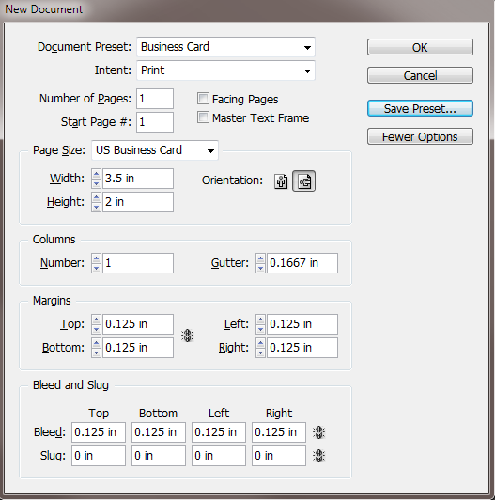

Place the Photoshop Picture
You’ll have the image bleed off the card, so use the Scale tool to resize the image to fit within the card’s outside edges. Use the Selection tool to resize the picture frame to form neat edges.
Task:
- Create a frame over the left 2/3 of the document
- Place “looking-up.psd” within the frame
- Choose (right-click) Fitting – Fit Content Proportionally
- Scale the picture proportionally within the frame
- Adjust the picture position within the frame

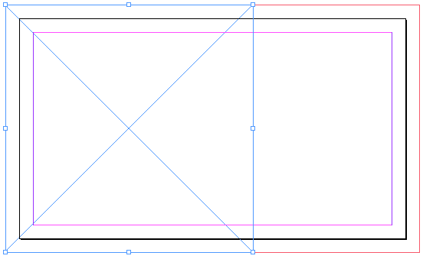

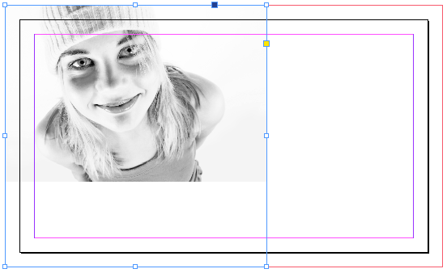

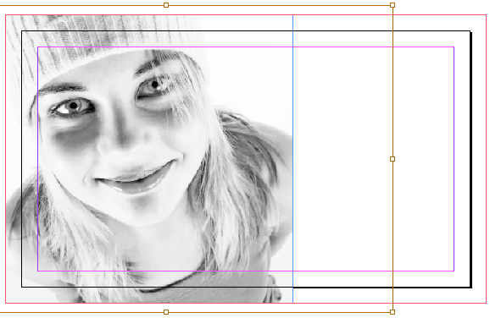

Place the Illustrator Logo
Task:
- Create a frame for the Logo
- Place “logo.ai” into the frame
- Choose (right-click) Fitting – Fit Content Proportionally
- Scale the picture proportionally within the frame
- Adjust the picture position within the frame

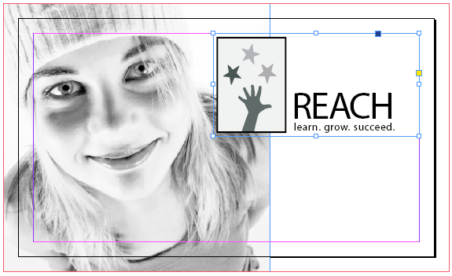

Add Additional Text
Task:
- Create a text frame for the address and contact information
- Add the following text, chose any font and font style (I used Myriad Web pro 8 pt and 10 pt)
  - Your Name
  - 15-285 Learning Lane
  - Lake Success, NY 11020
  - 516.555.8000
  - www.reachforlearning.com

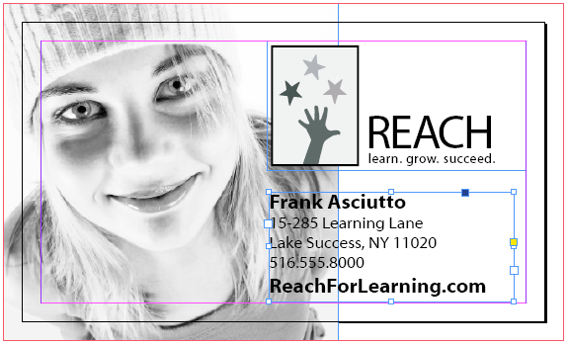

Adding and Adjusting the Graphics
Although the card is shaping up nicely, the image in the background is demanding too much attention. Changing the opacity of the image will result in a more subtle background.

Task:
- Select the image with the Selection tool, and change the Opacity setting in the Control panel
to a value of 25%

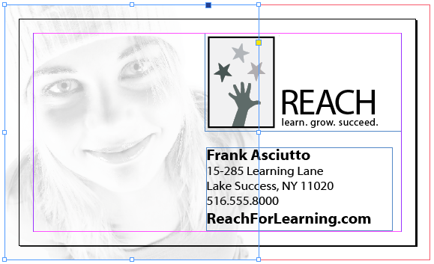

Although the faded image looks good, it might be more effective to bring out the face along the left side with a gray overlay.

Task:
- Use the Rectangle tool to create a shape over the left one-third of the card
  - No stroke, fill color to black
- Change the Opacity setting in the Control panel to 20%
- To create additional emphasis, use the Line tool to create an 80% black bar between the face and the logo on the card

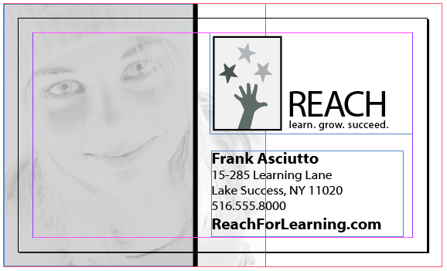
Finish the business card with a great quote.

Task:
- Create a new text frame and type:
“The wisest mind has something yet to learn..”
- Add the following text, chose any font and font style (I used Myriad Web pro 14 pt)
- Set the font color to white
- Save it as “business card.indd”

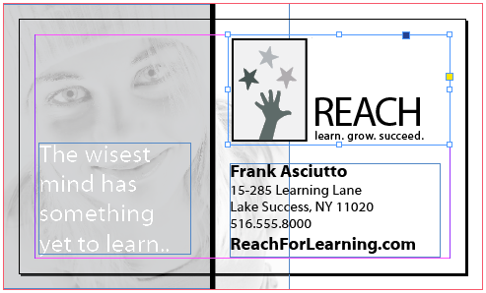

Final viewed in Preview mode:



Project 4 - Designing the Letterhead
Next you’ll design the letterhead, which is very similar in design to the business card you just made. Rather than redoing all the work you did for the business card, simply open the business card file and copy all the contents from it. The business card elements carry over to the letterhead.
Task:
- Create a new InDesign document with these settings:
  - Uncheck ‘”Facing Pages”, Portrait orientation
  - Letter size 8.5 × 11
  - Set your margins to 0.375 inches all around
  - More Options button to set a Bleed of 0.125 inches all around
  - Save it as a preset as “Letterhead”
- Copy and paste all the contents of the business card to the letterhead
- Move and scale the document elements to look similar to the example below Save it as “letterhead.indd”
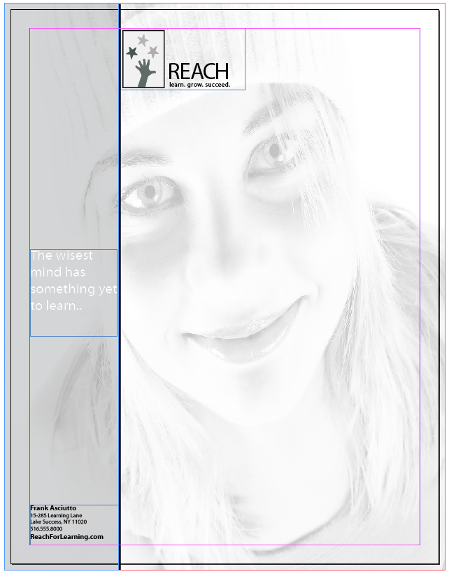

Project 5 - Designing the Envelope
Finally, create a standard #10 envelope. Similar to the Letterhead, create a new InDesign file and copy the logo and address.
Task:
- Create a new InDesign document with these settings:
  - Uncheck ‘”Facing Pages”, Landscape orientation
  - Document size 9.5 × 4.125 inches
  - Set your margins to 0.375 inches all around
  - You don’t need a bleed because you won’t be using the photo
or background colors in this design
  - Save it as a preset as “Envelope”
- Copy and paste the logo and address to the envelope
- Remove the address name, phone number and web address
- Move and scale the document elements to look similar to the example below
- Save it as “envelope.indd”



