- Start Fireworks and create a new document with the default size of 660x440. Save the file as buttons.png inside a new folder.
- Create two buttons in two separate layers defined as up and over. Note the difference Fireworks makes between layers and images. Make sure your buttons are in the same location in both layers.
- In the example below, the buttons shape has an inner bevel edge sloped filter applied.
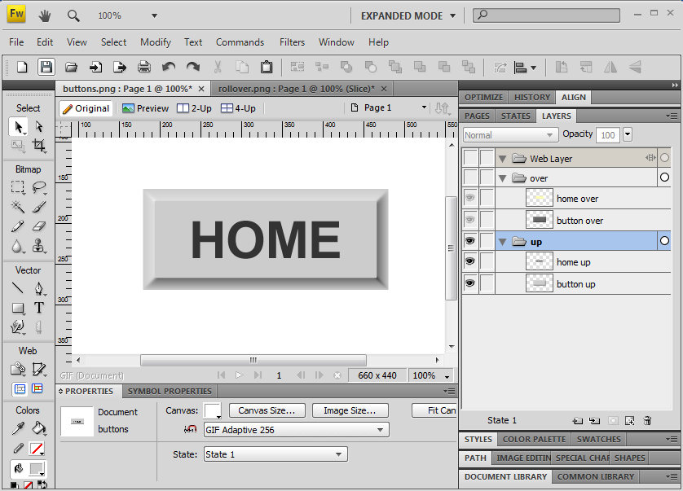
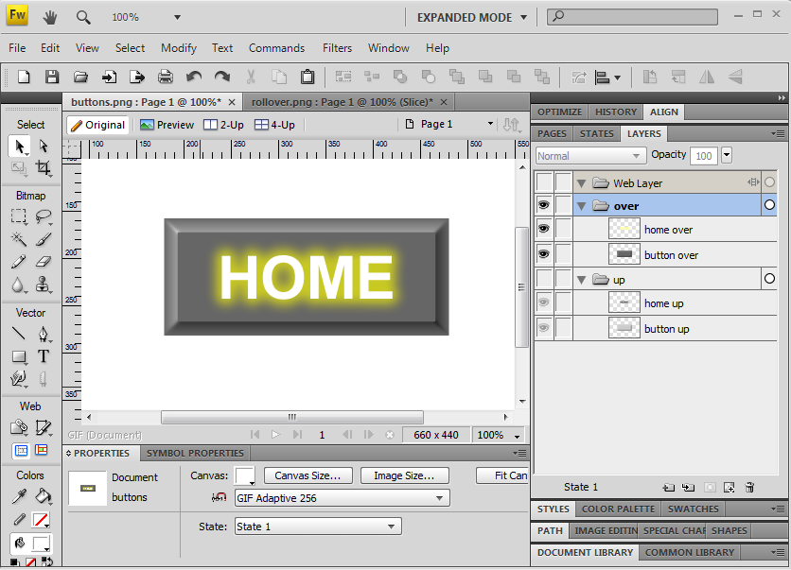
- Turn on visibility for the up layer and turn off visibility for the over layer.
- In the states panel, rename the state as up state.
- Duplicate the state, rename it to over state.
- Turn off visibility for the up layer and turn on visibility for the over layer.
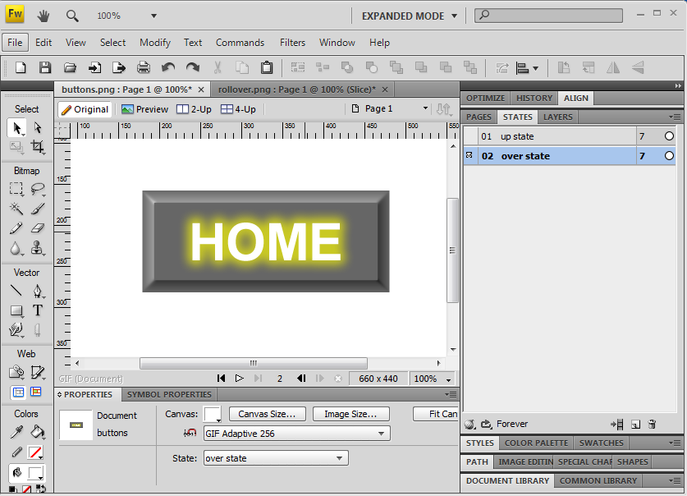
- Toggle between states to manually see the rollover action.
- Create a slice around the button. Note the new web layer image.
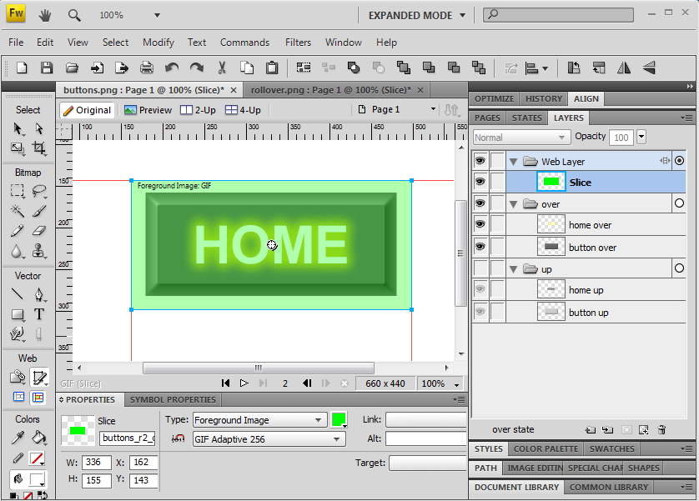
- Click on the slice and open the Behaviors panel. Click on the '+' button and choose Simple Rollover. Click on OK.
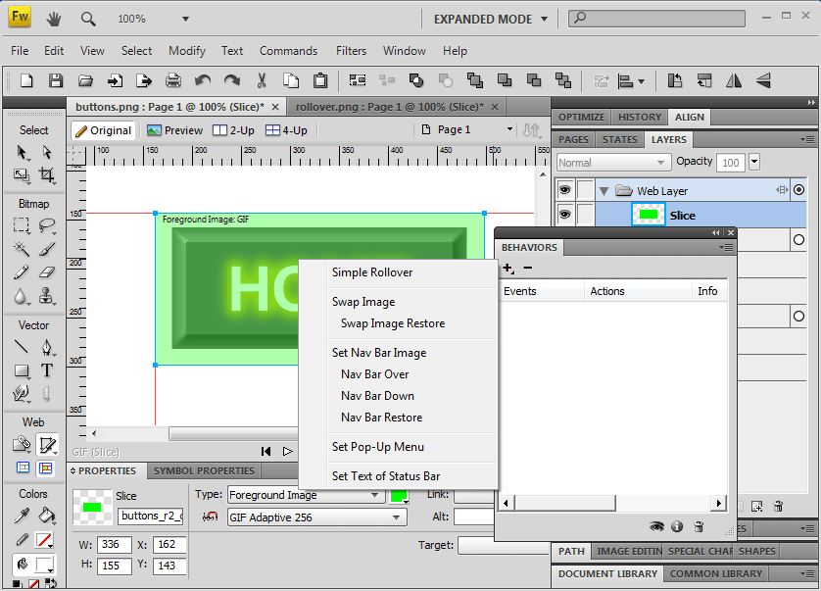
- Save your work.
- Choose File>Export to create an html page and the rollover images (accept the defaults).
- Test your work.

