Website Design with Dreamweaver & Fireworks

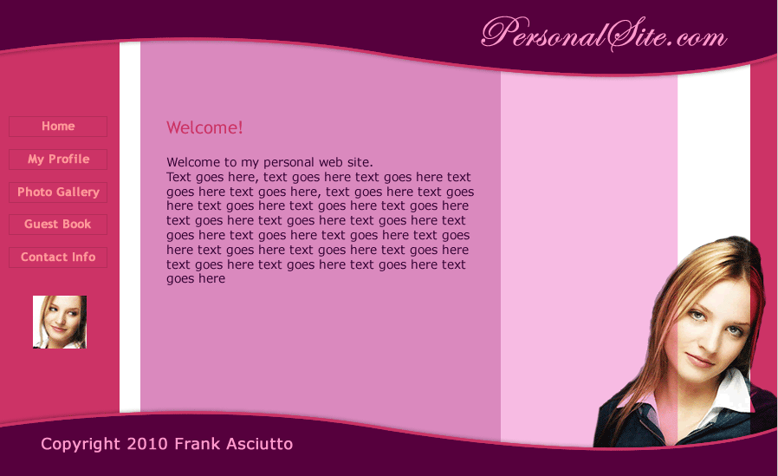

Color Palette - Purple & Pink Passion

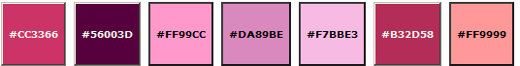

Design Steps
- Layout Design: Designing the website's layout with Fireworks
  - Designing the website's header and footer
  - Designing the website's background and navigation
  - Placing photos and content into the website's design
- Export Images: Slicing and Exporting the website images with Fireworks
- Dreamweaver Site: Setting up the website in Dreamweaver
- CSS: CSS and XHTML website programming with Dreamweaver
- CSS Styles: Formatting the web pages using CSS style sheets in Dreamweaver

1A) Layout Design - Designing the website's Header and Footer
- Create a new document in Fireworks with the dimensions of 900 x 550 pixels.
- To do this open Fireworks, select File >> New (Ctrl+N), the 'New Document' properties window will pop-up (see image below), where you need to enter the Canvas Size as Width: 900 pixels, Height: 550 pixels, Resolution: 72 pixels/inch and the Canvas Color to be white.
- Click the ok button and your document window will appear.
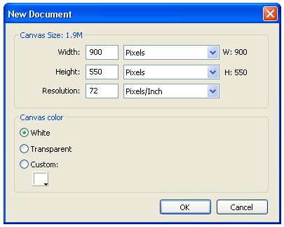
Designing the Header
We are going to design the header part of the design (purple curve with the site name “PersonalSite.com”). To do this:
- Create a curve for the header: Using the Rectangle Tool which is displayed under Vector on the left hand side of the tool bar (Window >> Tools) - draw a rectangle with the dimensions of 900x139 (width: 900 and height: 139).
- Now select the rectangle set Stroke color as #CC3366 and Fill color as #56003D. The Stroke colors and Fill colors are displayed under Colors on the left hand side of the tool bar (or in the properties panel). Set the Stroke Category to Pixel Soft (Pencil >> 1-Pixel Soft) and the Tip size to 4 pixels.
- Now you are going to convert the rectangle to a neat curve using the Subselection Tool and the Pen Tool . Look at the example below, you will see how you can step-by-step create a uniform curve.


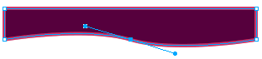
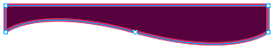
- Step 1: Click on rectangle and select one of its points using the Subselection Tool . While selecting the point Fireworks might tell you that the object is going to be ungrouped, click ok.
- Step 2: Using the Pen Tool place a point on the bottom line of the rectangle (approximate center) and without releasing the point drag your mouse (click+drag). The curve handles of the point will appear. Release the click.
- Step 3: To adjust the curve, just click the point just created and adjust the curve by clicking and dragging either of the curve handles.
- Now you have converted the rectangle to a neat curve. You now need to make the top and side lines of the curved box invisible. To do this first increase the size of the curve as 909 pixels (W: 909 pixels) using Scale Tool and move the curve slightly (X:-2 pixels and Y:-36 pixels) outside the document window (anything outside the document window is becomes invisible). Note: The W, H, X and Y are displayed under Properties (Window >> Properties). See the picture below to see how your curve should appear.


- Now we need to apply a shadow effect to the curve. Click to select the curve. Now on the right side of the properties window, you will find Filters, click over the + symbol and choose Drop Shadow from Shadow and Glow option. Click on the tiny blue circle with "i" next to the Drop Shadow filter (Edit and arrange live filters button) and set the following values for the filter: Opacity – 30%, Softness – 4, Angle – 319, Distance – 3, Color - #000000.
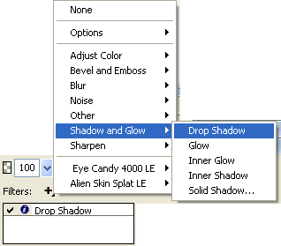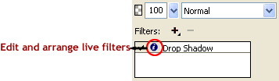
- Create the site name text: Click the Text tool , choose Font - Edwardian Script ITC, Font Size - 50, Color - #FF99CC, Font Weight - bold, Anti-aliasing level - Smooth Anti-Alias and write your site name (as you like) on the right hand side of your curve, we have used 'PersonalSite.com' as the site name. The image below shows the Properties Window in which you can set the font type, size and color:

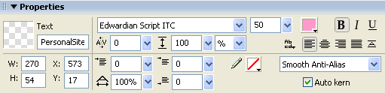

You have successfully created the header part of the design with Fireworks. The header should finally look similar to the below image:


Designing the Footer
The effect used in the footer of our design is the same as the effect used in header, except that the curve is reversed in direction.
- To create the footer curve, select the header curve with the Pointer Tool and then press "Alt + down arrow" (or copy-paste) to duplicate it.
- Select and move the duplicate curve down so all its points are visible. Now select the above two points (straight line) using the Subselection Tool as shown below. Press "Shift + down arrow" to move the line vertically down till it goes below the points of the curve. See the illustration below that shows how to create the footer curve.
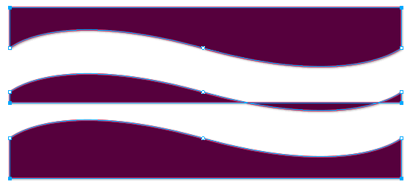
- Adjust the shadow of the footer curve by clicking the Edit and arrange live filters (tiny blue circle with "i") next to Drop Shadow and set its angle to 151, so that the shadow now appears above the curve.
- Create the footer text: Click the Text Tool , choose Font - Verdana, Font Size - 10, Color - #FF99CC, Anti-aliasing level - No Anti-Alias and write your footer text on the left hand side of the footer curve.
You have now completed the first step in creating your own website - Header and Footer design. The resultant design should look similar to the below image.


1B) Layout Design - Designing the web-site's background and navigation
Before creating the background and navigation of the Fireworks website layout created so far, please double click and rename the layer containing the previously designed header and footer (named as "layer 1" by default) to "header and footer" and then lock the layer.

Designing the web-site Background
Create a new layer by clicking the Option on the right side of the Layers Panel and rename the layer as background and navigation. Now click and drag the background and navigation layer below the header and footer layer. See the below image that shows how the layers should now appear.
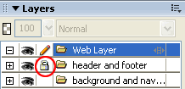
Lets now learn how to create the multi-colored background as shown in the sample design.
- First you need to draw a rectangle with the dimensions of width: 142 pixels and height: 508 pixels using the Rectangle Tool . Select the rectangle and set its Fill Color as #CC3366 and Stroke Color as none. Now, place your rectangle on the left side of the Document Window.
- Duplicate the first rectangle (copy-paste or Alt+down arrow) OR draw a second rectangle with the dimensions of width: 32 pixels and height: 508 pixels using the Rectangle Tool . Select the second rectangle and set its Fill Color as #CC3366 and Stroke Color as none. Now, place your rectangle on the right side of the Document Window. The image below shows how the website layout should look like now:

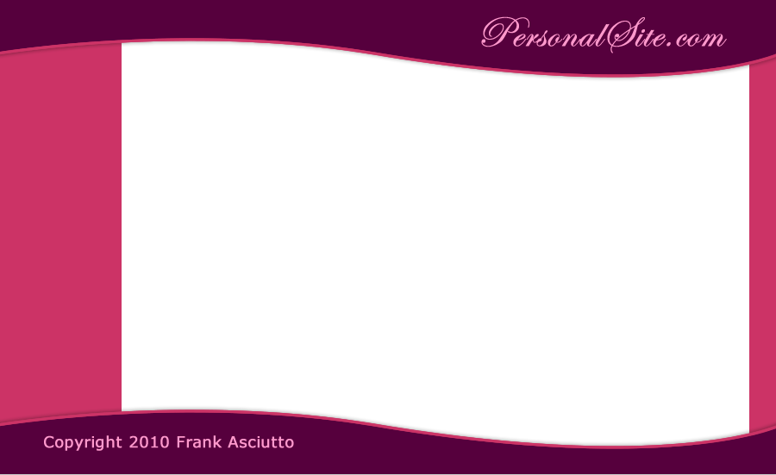

- Next you need to similarly place another two rectangles in between the first two rectangles to complete our website background design using Fireworks.
- Draw a third rectangle with the dimensions of width: 463 pixels and height: 508 pixels using the Rectangle Tool .
- Select the rectangle, and set its Fill Color to #DA89BE and Stroke Color as none. Now, place your rectangle on the left side of the Document Window (Set the XY position to about X: 169 and Y: 16). Note: The W, H, X and Y values can be viewed in the Properties Inspector (Window >> Properties).
- Draw a fourth rectangle with the dimensions of width: 169 pixels and height: 508 pixels using the Rectangle Tool . Select the rectangle, choose Fill Color as #F7BBE3 and Stroke Color as none. Now, place your rectangle on the left side of the third rectangle as shown below (The XY position should be about X: 593 and Y: 66). The image below shows the resulting layout:
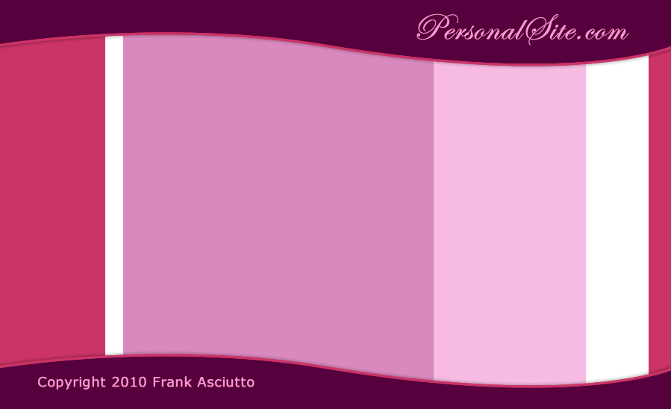
You have now completed the background of the website design in Fireworks.
Designing the web-site Navigation
- In our sample design the first vertical bar on the left will be used to place the website's navigation links. We are going to use five links such as Home, My Profile, Photo Gallery, Guest Book and Contact Info as the website's navigation links.
- To create the links, first draw a rectangle with the dimensions of width: 114 pixels and height: 24 pixels. Select the rectangle and set its Fill Color as none and Stroke Color as #B32D58. Now duplicate (Alt + down arrow) the rectangle four times and arrange the rectangles one by one.
- Take the Text Tool , choose Font - Trebuchet MS, Font Size - 14, Color - #FF9999, Font Weight - bold, Anti-aliasing level - Smooth Anti-Alias and write the text of the links. See the illustration below that shows how the links are arranged.
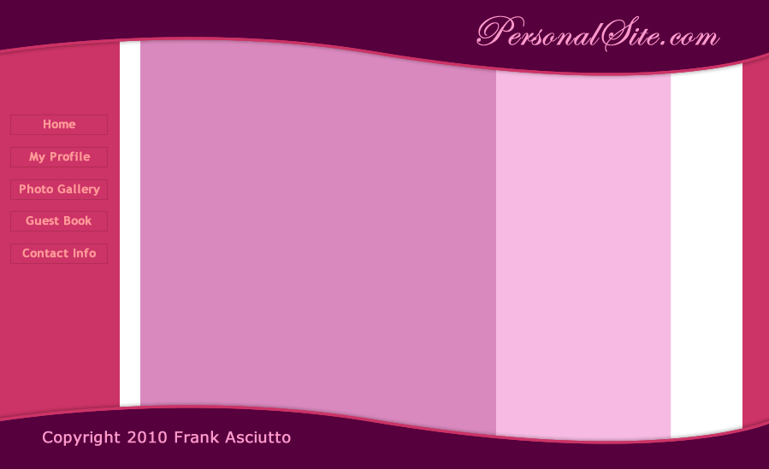

1C) Layout Design - Placing website photos & content
The final step in the layout design process is to place your images. In this layout we have used two images of the girl, one in the footer and one in the left menu.
Placing the Footer Photo
While using pictures in designing we often need to extract a particular part of the image. For this we can use any one of the various image extraction techniques possible in Fireworks. Basically we will remove the unwanted parts of the image with the magic wand tool and then smooth out the jagged finish with the eraser tool. This cool effect makes your pictures stand out and look really professional. Lets now learn how to extract the photo as shown in the sample design.
- Open a new Fireworks file and go to File >> Import (Ctrl+R) the image you would like to place in the design. Our example is shown below:

- Select the background black area that you would like to delete using the Magic Wand tool and adjust the Tolerance level as 9 and Edge as Anti-alias. Tolerance represents the tonal range of colors that are select when you click a pixel with the magic wand tool. The Tolerance level is displayed in the Properties Inspector (Window >> Properties). After selecting the area satisfactorily, delete it. See the illustration below that will show how to set the tolerance level:
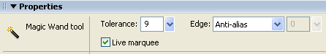
- Once you have deleted the unwanted area you should get an image similar to the one shown below, the edges will be jagged and uneven.

- Now we need to smooth the edges using the Eraser Tool . Use the round eraser with some opacity (e.g. 50) and edge softness (e.g. 10). The image above shows how the edges are smoothened with the eraser tool and the final smooth edges image is shown below.

- Copy this image and paste the image to the right bottom of the layout (work space) in the background and navigation layer. Select the image and set it's Blend Mode as Multiply. The Blend Mode is displayed on the right side of the Properties Inspector. See the image below that will show where the Blend mode option will appear. After applying the Multiply Blend Mode the image will blend into the background of your layout.
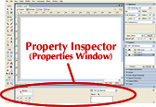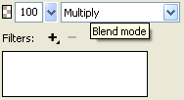
Placing the Left Menu Photo
- We have used a second image in the design - the one under the navigation links. To place this photo into your design you need to first import (Ctrl+R) the image into your layout design. Click the image, select the Scale Tool and then resize your image to width 103 pixels and height 102 pixels.
- Now draw a rectangle using the Rectangle Tool width: 114 pixels and height: 112 pixels. Now set the Stroke Color to #B32D58 and set its Fill Color to the color of the menu area using the Color Picker. Now place the rectangle below the navigation links and the image on it.
- Finally you need to paste the image inside the rectangle. Click and cut (Ctrl + X) the image. Then, select the rectangle and press Ctrl+Shift+V to paste the image inside the rectangle. Your layout in Fireworks should now look similar to the image below:
Insert Sample Content
To get an idea of how your website will look with the content inserted after converstion, its important to place some sample text on the designed layout. This will also help you in deciding the fonts and colors required for your text in the CSS styles formatting stage with Dreamweaver CS4.
- For the website text we have chosen the Font - Verdana, Font Size - 13, Color - 330033, Anti-aliasing level - Crisp Anti-Alias. Similarly for the title we have chosen the Font - Trebuchet MS, Font Size - 18, Color - #CC3366, Anti-aliasing level - Smooth Anti-Alias and Font Weight – Bold. Your final layout design in Fireworks should look similar to the image below:

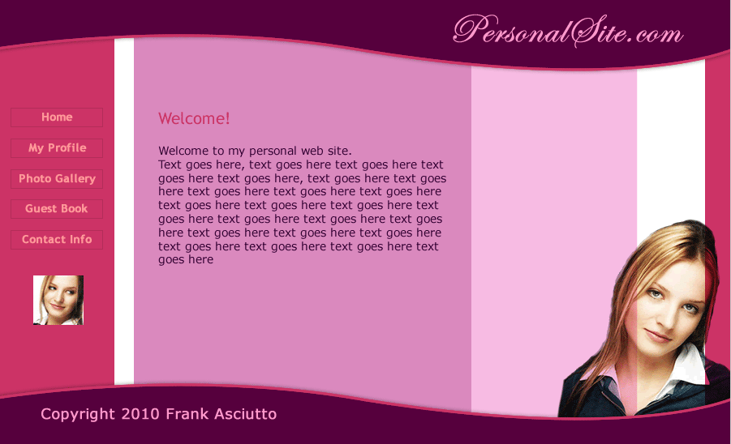
2) Export Images: Slicing and Exporting the website images with Fireworks
The term slicing in Fireworks means to cut the a designed image into smaller pieces for optimal use as smaller images download more quickly over the web. Rather than waiting for one large image to download, a web page would load faster if it consisted of several smaller images that load simultaneously into the browser to display the design. In addition, slicing makes it possible to optimize various parts of a document differently.
Web Layer: In Fireworks the slices are stored in the Web Layer located as the first layer in the Layers panel. The Web Layer is always on the topmost layer in any document.
Step 1: In our designed layout you are going to take slices for the design elements in the header, footer and navigational links menu. The text in the content area needs to be ignored as it isn't needed as images (just make the "content" layer invisible). Before that we recommend you save a copy of your PNG file as a backup of the original design.
Step 2: Now, select the header curve (unlock the header and footer layer first) and insert a slice on it. To do this go to Edit > Insert > Rectangular Slice. A rectangular slice is inserted on top of the header part. Fireworks Slices have a green overlay by default. The slice created will have a default slice name of “layout_r1_c1”; rename the slice as "header". The slice name should make sense when you export it as an image. The slice name will display under the Properties Inspector (Window >> Properties).
Step 3: Similarly create slices for the footer curve and photos (The girl's photo that is displayed on the right bottom and under the links) - name the footer slice "footer", the smaller photo slice "avatar" and the bottom photo slice "footerT". While taking the slice for the footer photo modify the slice using the Scale Tool to cover only the head portion that is seen above the footer slice (without overlapping) - refer to the image below that illustrates this. Since the remaining body portion is covered in the footer slice, you don’t need to take slice for the whole image.
Step 4: The final slice we need to take is for the website's vertical fill image. A fill image is a small part of a repeatitive design and is used as a background image to repeat and cover the entire area it is the background of. You will need to hide the navigation layer (i.e. the links) before taking this slice. Select the Slice Tool and drag-draw a slice the width of the design document 900 pixels and height 5 pixels. name the slice "content_fill". The illustration below shows how the parts of the design are sliced and named:
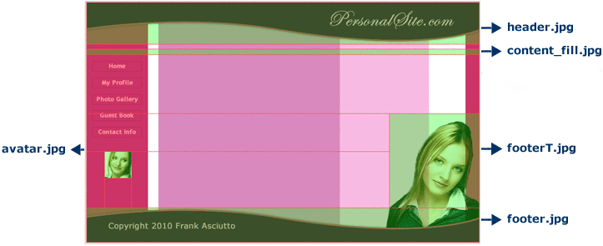
Note: Make sure none of the slices overlap each other as in the figure above. To check this you can zoom in by pressing Ctrl + (plus) and to zoom out by pressing Ctrl - (minus).
Step 5: Open the Optimize Panel (Window >> Optimize or press F6) and select each slice using the Pointer Tool and select file type "JPEG - Better Quality". Now set the Quality as 80.

Exporting Images from Fireworks
To export images means to convert and save the sliced design parts as GIF or JPEG files for further use.
Step 1: Go to File > Export, the Export window will pop-up.
Step 2: In the Save in field first select a local folder on your computer as the website's root folder - now create a new folder called images inside it in which to export the sliced images - select the images folder by entering it. The Export field will have the HTML and Images option selected by default, change this to Images Only; select Export Slices for the Slices option; Untick the option Include areas without slices. See the illustration below that will show the Export window. Now click the Export button and your sliced images will be exported and saved in the selected images folder.
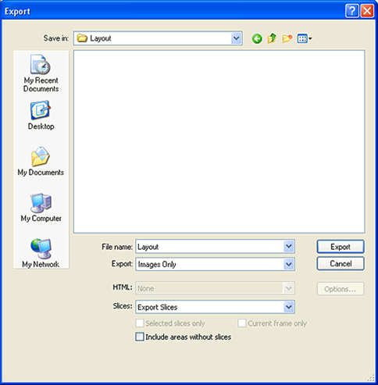
You have now successfully sliced and exported the designed website's images.

3) Setting up your website in Dreamweaver
Once you have completed your website design, you need to setup your website in Dreamweaver to start the website building process.
Please follow the below steps to setup your website in Dreamweaver:
- Inside Dreamweaver open the Manage Sites pop-up window by clicking Site (Site >> Manage Sites). The Site menu is shown below:
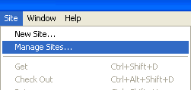
- In the Manage Sites dialog box, you can create, edit, duplicate, remove, export, and import Dreamweaver site definitions. To define a new site, click the New button in the Manage Sites pop-up window and choose Site. The image below shows the Manage Sites dialog box:
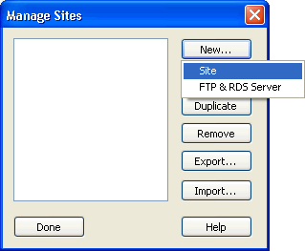
- Click the Advanced tab in your Site Definition for Layout window that pops up. Here you need to type your Site name and click on the folder icon in the right side of Local root folder to locate your local website directory (inside which you have the images folder to which you exported the image slices from Fireworks). The "Site Definition for Layout window" is shown below:
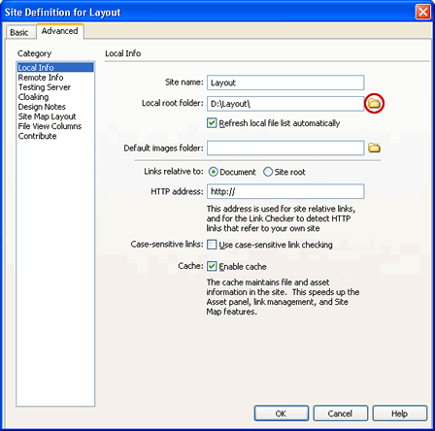
- After selecting the local root folder, click Ok. Now, All your Files will display in the Files Panel. The image below shows the Files panel in Dreamweaver:
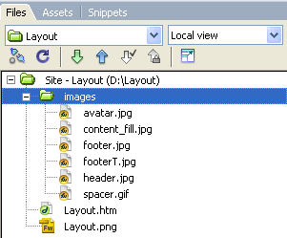
You have now completed the Dreamweaver site set-up step.

4) CSS and XHTML website programming with Dreamweaver

Once you have set-up your web site using Dreamweaver you are ready to program your website with CSS and XHTML programming. This is the second step in building your designed and exported website with Dreamweaver.

Now you are going to learn how use the exported images in Step 2 to create your XHTML page with Dreamweaver using CSS and XHTML programming. See the illustration below that will show how your DIVs are arranged for the index.xhtml file in Dreamweaver.

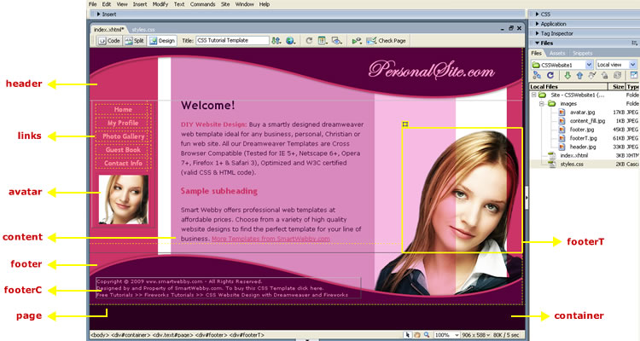

HTML Programming
Step 1: Let us first create your HTML page. In Dreamweaver, the files will be displayed in the Files Panel (Window >> Files or F8) under Local Files. Right click on the first folder visible in the list with the Site Name; now select New File. A new html file will be created in your website folder. Rename the file as index.html. Now double click on it so the document opens up.

Step 2: In the index.html document left top you will find three buttons Code, Split and Design to access different views. Click the Code View button; Select all (Ctrl+A) and delete. Now copy-paste the code shown below into it and save your file:

<!DOCTYPE html PUBLIC "-//W3C//DTD XHTML 1.0 Transitional//EN" "http://www.w3.org/TR/xhtml1/DTD/xhtml1-transitional.dtd">
<html xmlns="http://www.w3.org/1999/xhtml">
<head>
<meta http-equiv="Content-Type" content="text/html; charset=iso-8859-1" />
<title>Website Design with Dreamweaver & Fireworks</title>
<link rel="stylesheet" type="text/css" href="styles.css">
</head>
<body>
<div id="container" align="center">
<div id="page" class="text" align="left">
<div id="header"></div>
<div id="links" align="center"><a href="#">Home</a> <a href="#">My Profile</a> <a href="#">Photo Gallery</a> <a href="#">Guest Book</a> <a href="#">Contact Info</a> <img src="images/avatar.jpg" alt="" width="114" height="112" border="0" vspace="2" hspace="8" /></div>
<div id="content"><h1>Welcome! </h1>
<p>Sample Text.</p>
<h2>Sample subheading </h2>
<p>Sample Text.</p>
</div>
<div id="clearfloats"></div>
<div id="footer" align="left"><div id="footerT"><img src="images/footerT.jpg" alt="" width="250" height="260" border="0" /></div>
<div id="footerC">
<p>Copyright &copy; 2010 Frank Asciutto</p>
</div>
</div>
</div>
</div>
</div>
</div>
</body>
</html>

The code within the body tag contains the various DIV tags required to display the various parts of the design. See in the image above what each DIV tag displays. We have divided the layout into five general sections: header, footer, links, content and the footer picture top, apart from the page's background container.

Notice in the index.html page code how we have linked to an external style sheet called styles.css (which includes style specifications of the DIV tags shown in the screenshot above). The line of code that does this is shown below:
<link rel="stylesheet" type="text/css" href="styles.css">
Let us now create and see how this CSS style sheet works.
CSS Programming
Moving on to the CSS programming part:
Step 1: Right click the files panel as before and select New File to create a new document. A new html file will be created in your website folder. Rename the file as styles.css. Now double click on it so the document opens up.
Step 2: A style sheet has only one view, the Code view, and so will have no default code inside it (if it does, once again select all (Ctrl+A) and click delete). Now copy-paste the code shown below into it and save your file:

/* CSS Document */
body{
margin:0px;
padding:0px;
background:#2A001E;
color:#330033;
font-family:Verdana, Arial, Helvetica, sans-serif;
font-size:12px;
}
#container{
width:100%;
}
#page{
width:900px;
position:relative;
background:url(images/content_fill.jpg) repeat-y;
z-index:1;
}
#header{
width:900px;
height:110px;
background:url(images/header.jpg) no-repeat;
}
#links{
position:relative;
float:left;
left:5px;
top:0px;
margin-bottom:30px;
width:114px;
}
#links a{
color:#FF9999;
font-size:14px;
font-weight:bold;
font-family:"Trebuchet MS", Verdana, Arial, Helvetica, sans-serif;
text-decoration:none;
display:block;
border:1px solid #B32D58;
margin:8px;
width:112px;
}
#links a:hover{
color:#FFFFFF;
}
#avatar{
position:relative;
float:left;
left:15px;
top:0px;
}
#content{
padding:0px 330px 0 190px;
line-height:20px;
z-index:2;
}
#clearfloats{
clear:left;
}
#footer{
clear:both;
width:900px;
height:108px;
background:url(images/footer.jpg) no-repeat;
}
#footerT{
position:absolute;
float:right;
bottom:108px;
right:0px;
height:260px;
width:250px;
z-index:3;
}
#footerC{
position:relative;
top:53px;
width:550px;
margin:0 20px 20px 14px;
color:#FF99CC;
font-size:10px;
line-height:15px;
}
#footerC a{color:#FF99CC;text-decoration:none;}
#footerC a:hover{color:#FFFFFF;text-decoration:underline;}
All the ID attribute styles are for the various DIV tags that make up the design. Compare each ID style specification with the above screenshot to understand the basic logic of the CSS design.
You have now successfully created the XHTML & CSS web page layout using Dreamweaver.
The next step is to Format your web pages using CSS styles in Dreamweaver.

5) CSS Styles: Formatting the web pages using CSS style sheets in Dreamweaver
Once you have XHTML & CSS programmed your website using Dreamweaver you need to format your web page text content using CSS Styles
- CSS Styles: Using Dreamweaver for CSS Styling Text
- Format your web page text content using CSS style sheets in Dreamweaver

So far you have learned how to program your website's layout using Adobe Fireworks. Once you have programmed your website design, you need to format your website text using CSS style sheets in Dreamweaver. For this you need to open the styles.css file you created in the previous step. Now add the following styles for formatting your web page text elements.

Title
The Title in the content area should be a H1 tag. Copy-paste the following style and make any necessary modifications:
h1 {font-size:24px; color:#330033; font-family:"Trebuchet MS", Verdana, Arial, Helvetica, sans-serif; margin-top:0;}

Subheading
The subheading in your web page should be a H2 tag. Copy-paste the following style and make any necessary modifications:
h2 {font-size:18px; color:CC3366; font-family:"Trebuchet MS", Verdana, Arial, Helvetica, sans-serif;}

Subtitle
We have used a class style called subtitle to use on a few words within a paragraph of text. Copy-paste the following style for it:
.subtitle {font-weight:bold; color:#CC3366;}

Links
To set the colors for any links in your content stylize the A tag and its hover property. To do this use the following styles:
a {color:#CC3366;} a:hover {color:#FFCCFF;}

Great job! You have now completed the CSS style sheet for your website.
Open index.html and Press F12 to view your completed web page design in the browser.

