3D Circle Animation in Flash
Using this lesson, you will see how to create a circle that is rotate 3D.

Step 1
Open a new flash document.
Step 2
Select Modify > Document (shortcut key: Ctrl+J ).
Set the dimension at whatever you want.
Set the background color as whatever you like (You can use some picture as background to make this lesson more attractive).
Set your Flash movie's frame rate to 42.
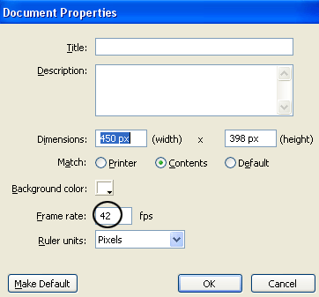
Step 3
Take the Oval Tool (O). In the Colors portion of the Tool panel, block the fill color by clicking on the little paint bucket icon and then on the small square with the red diagonal line. For Stroke color choose any color, and choose Solid as type of stroke, with thickness set to 4. Then, draw a circle. See the picture below.
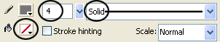
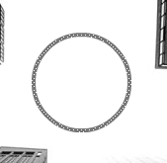
Step 4
While the circle is still selected, press F8 key (Convert to Symbol) to convert this circle into a Movie Clip Symbol.
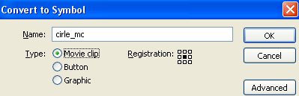
Step 5
Click on frame 15 and press F6 key.
Step 6
While you're still on frame 15, choose Modify > Transform > Flip Horizontal.
Step 7
Right-click anywhere on the gray area between the two keyframes on the timeline and choose Create Motion Tween from the menu that appears.
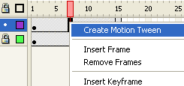
Step 8
Double click on layer 1 to rename its name in circle 1. After that, take the Selection Tool (V), select the all frames of layer circle 1, choose right click and Copy Frames. See the picture below.
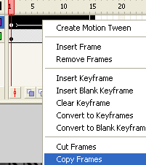
Step 9
Then, create a new layer above the circle 1 layer, name it circle 2 and, click on the first frame, choose right click and Paste Frames. See the picture below.
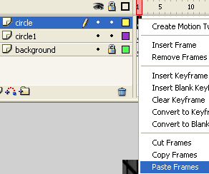
Now you have this:
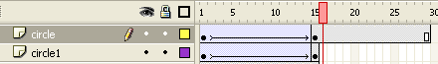
Step 10
Take again the Selection Tool (V), and select the all frames from frame 15 to frame 30, choose right click again and Remove Frames.
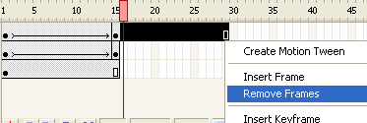
Now, you have only this:
Step 11
Take again the Selection Tool (V) and click once on the circle 2 layer to select it. Then, using the mouse, or by arrows key, move the circle that you just copied a little left. See the picture below.
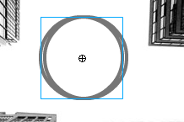
That's it!
Test your Movie (Ctrl+Enter).

