Project Overview
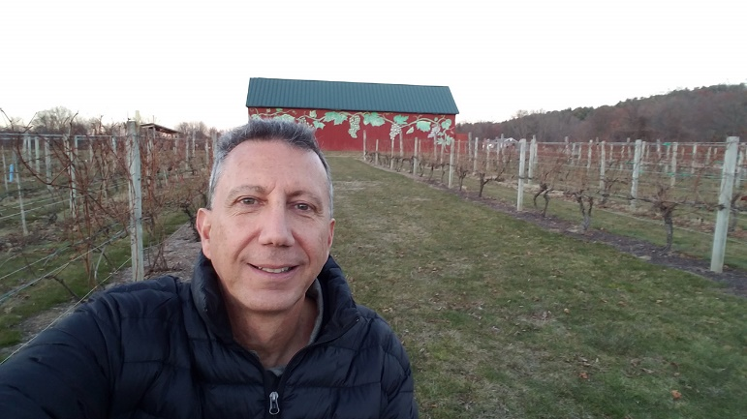
Convert any picture to a cartoon effect in Photoshop. Download and unzip the project files from: http://www.asciutto.com/hhs/
Start

Project Summary
1) Top Layer
- Create an Outline
- Adjust and Touch-up
- Stylize/Oil Paint
2) Bottom Layer
- Colorize
- Adjust and Touch-up
- Stylize/Oil Paint
3) Blend Layers

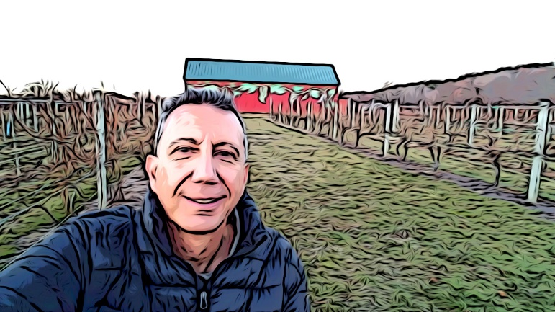
1) Document Set-up
Final
- Open Frank_Cartoon_Start.jpg
- Save it as a Photoshop .psd file

2) Create the Outline
Copy the Background layer and rename it Outline.
Apply the Filter > Poster Edge with these settings:
- Edge Thickness 10
- Edge Intensity 5
- Posterization 2

3) Adjust the Outline
Image > Adjustments > Threshold
- Push the adjustment slider to the left to create an ink outline drawing.
- A setting of less than 30 is normally good for most picture
- For this picture, I set it to 1

4) Touch-up the Outline
Set the Foreground color to White
With a small Brush, touch-up the Outline by painting over any black spots you think are too intrusive on the picture. For this picture, I removed some of the black spots on my face.

5) Stylize the Outline
This will smooth the Outline. These setting are down to personal taste. I used:
Filter > Oil Paint
- Stylisation 5
- Cleanliness 2
- Shine 0

6) Create the Color Layer
- Select the Background layer and duplicate it again
- Rename it Color (this will sit below the Outline layer)
- Turn off visibility of the Outline layer

7) Filter the Color Layer
Filter > Poster Edge
- Edge Thickness 0
- Edge Intensity 0
- Posterization 2

8) Adjust the Color Layer
This will lighten the picture, reduce contrast and enhance the color.
Image > Adjustments > Levels
- Move the Output slider slightly to the right
  - I set it to 30
- Move the Highlight slider slightly to the left
  - I set it to 220
Image > Adjustments > Hue/Saturation
- Move the Saturation slider to the right to increase color and add vibrancy to the picture
  - I set it to 40

9) Stylize the Color Layer
This will create a brush feel.
Filter > Oil Paint
- Stylisation 5
- Cleanliness 7
- Shine 0

10) Apply the Outline
Turn on visibility of the Outline layer
- Set the Blend Mode to Multiply

11) Adjust the Final
Add a top adjustment layer for Shadows/Highlights.

Extra
- Repeat the process for a picture of yourself. Try tweaking some of the steps with different settings.
- Create an Action the will contain all of these steps and apply the Action to other pictures.

