Big Red Barn Stylized Text – Photoshop Project

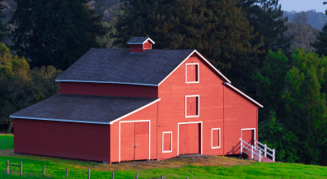
Step 1: Download and save the Big Red Barn picture from: http://www.asciutto.com/hhs/ Open the picture in Photoshop, unlock the Background layer (making it Layer 0) and save it as a .PSD file.
Step 2: Type “BIG RED BARN” in a new text layer, all caps, any color, font: Impact, size: 150.
Step 3: Convert the text into a selection: ctrl + click on the text layer thumbnail.
Step 4: On the text layer, add a Layer Mask based on the selection: select “Add layer mask” from the short-cut icons on the bottom of the Layer panel.
Step 5: Select the Mask thumbnail in the text layer and drag it to Layer 0, the picture layer.

Step 6: Delete the “BIG RED BARN” text layer. It is no longer needed. We used it to create the layer mask.

Step 7: Unlink the mask thumb to the picture thumb: click the chain between both.
Step 8: Select the mask and position it over the part of the picture you want to reveal.
Step 9: Optional: Crop to the text mask.

Step 10: Create a new layer, label it “white”, and move it to the bottom of the layer stack. Fill it with white color: Edit > Fill > Contents: White.
Step 11: Select layer 0 and apply layer styles: layer menu – blending options. Experiment with different styles, such as drop shadows and bevel & emboss.
Step 12: Save for web to create .jpg or .png formats.
Original Picture:

Final:


Final Photoshop Layer Panel (CS6):

